Power BI, Power Apps, Power Automate Integration Scenarios

1. Automated Reporting with Power Automate and Power BI

* Scenario: Power Automate can trigger a flow to refresh Power BI datasets or reports based on a schedule or event.
* Example: Automatically refresh Power BI dashboards whenever a new row is added to a SharePoint list or a SQL database table.

2. Power BI Alerts Triggering Power Automate Flows

* Scenario: Create alerts in Power BI for key metrics, and use Power Automate to trigger workflows when those alerts are met.
* Example: When a sales target is exceeded in Power BI, send a notification email or create a task in Microsoft Planner using Power Automate.

3. Embedding Power BI Reports in Power Apps

* Scenario: Embed interactive Power BI reports within Power Apps to provide users with visual insights as they interact with the app.
* Example: A Power App for inventory management can display real-time inventory insights from a Power BI report, helping users make informed decisions.

4. Trigger Power Automate Flows from Power Apps

* Scenario: Users can trigger Power Automate workflows directly from a Power App interface, enabling automated processes without leaving the app.
* Example: A user submits a request form in Power Apps, which triggers a Power Automate flow to send approval emails and update SharePoint records.

5. Collect Data with Power Apps and Analyze in Power BI

* Scenario: Power Apps can be used to collect and update data, which can then be analyzed and visualized in Power BI.
* Example: Field agents collect data through a Power App on their mobile devices, and this data is later visualized in Power BI for management to review and make strategic decisions.

6. Power Automate Flows to Update Power BI Datasets

* Scenario: Use Power Automate to push or update data in a Power BI dataset from various sources like Excel, SharePoint, or SQL.
* Example: A Power Automate flow extracts data from a new Excel file in OneDrive and updates the corresponding Power BI dataset for analysis.

7. Trigger Power Automate Flows from Power BI

* Scenario: Power BI visuals or reports can trigger Power Automate flows to start actions such as sending emails or writing data to external sources.
* Example: From a Power BI report showing overdue invoices, a user can trigger a flow to send reminder emails to clients directly from the report.

8. Using Power BI with Power Automate for Real-time Data Notifications

* Scenario: Power Automate can be used to send real-time notifications or updates based on changes in Power BI datasets or visuals.
* Example: When new survey results are uploaded, a flow automatically sends an update email to stakeholders with a link to the updated Power BI dashboard.

9. Power Apps Data-Driven Actions with Power BI Insights

* Scenario: Combine Power BI's data insights with Power Apps' functionality to enable users to take action based on analytics.
* Example: From within a Power BI report, a user can drill into an issue and directly open a Power App to resolve it, such as updating customer details or submitting a work order.

10. Create Workflows with Power Automate Based on Power BI Data

* Scenario: Power BI data can trigger workflows in Power Automate to automate tasks like data collection, report generation, or document approvals.
* Example: When a certain sales threshold is reached in Power BI, Power Automate generates and distributes a sales report to the executive team.

11. Automated Data Entry with Power Automate and Power Apps

* Scenario: Automate data entry from Power Apps into various systems using Power Automate, ensuring data consistency across platforms.
* Example: A Power App collects employee expense reports, and Power Automate automatically updates an Excel sheet or a SQL database with the report details.

12. Trigger Power BI Dataset Refresh from Power Apps

* Scenario: Use Power Apps to trigger on-demand refresh of Power BI datasets through Power Automate for real-time updates.
* Example: After entering new sales data in Power Apps, a user can press a button to trigger a Power Automate flow that refreshes the Power BI dataset to reflect the changes immediately.

13. Automated Approval Process for Power BI Report Sharing

* Scenario: Power Automate can automate approval workflows for sharing Power BI reports with stakeholders.
* Example: A user submits a request in Power Apps to share a Power BI report, which triggers a Power Automate approval process that notifies approvers and automatically shares the report upon approval.

14. Dynamic Power BI Reports Based on Power Apps User Input

* Scenario: Input from users in Power Apps can dynamically update data shown in Power BI reports, creating personalized dashboards.
* Example: Users select specific filters or preferences in Power Apps, and the embedded Power BI report updates in real time to reflect those choices.

15. Use Power BI Insights to Drive Process Automation in Power Automate

* Scenario: Power BI can track business metrics and use these insights to drive automation processes in Power Automate.
* Example: When a Power BI report shows a drop in sales performance, Power Automate triggers a flow to schedule follow-up emails or meetings with the sales team.

16. Embed Power Apps Forms in Power BI Reports

* Scenario: Embed Power Apps within Power BI reports to allow users to take actions directly from the report interface.
* Example: A Power BI report analyzing customer feedback embeds a Power App where users can update customer details or submit follow-up tasks for customer service teams.

17. Use Power Automate for Data Transformation Before Power BI Reporting

* Scenario: Power Automate can perform data transformations and cleanups before sending the data to Power BI for reporting.
* Example: A flow extracts data from an external API, formats it, and uploads it to a Power BI dataset for analysis and visualization.

18. Automate Notifications for Power BI Dataset Failures

* Scenario: Use Power Automate to monitor the health of Power BI datasets and notify stakeholders if a refresh or update fails.
* Example: If a scheduled Power BI dataset refresh fails, Power Automate sends an email or a Teams notification to the data owner for immediate troubleshooting.

19. Power BI-Driven Inventory Replenishment via Power Automate

* Scenario: Power Automate can trigger automated inventory restocking processes based on Power BI inventory reports and metrics.
* Example: When inventory levels fall below a certain threshold as shown in Power BI, Power Automate triggers a flow to place an order with the supplier automatically.

20. Power BI and Power Apps for Real-time Feedback Loops

* Scenario: Create a real-time feedback loop where Power Apps captures user input, updates Power BI reports, and Power BI insights trigger actions in Power Automate.
* Example: A user submits feedback through a Power App, which updates a Power BI dashboard in real time. Based on the feedback score, Power Automate triggers a follow-up action, such as sending a thank-you email or escalating an issue.

21. Power Automate for Report Distribution Based on Power BI Metrics

* Scenario: Automatically distribute customized Power BI reports to specific teams or stakeholders based on key metrics.
* Example: When sales in a specific region exceed a target, Power Automate generates a tailored report and sends it to the regional manager.

22. Create Dynamic Power BI Dashboards from Power Apps Input

* Scenario: Allow Power Apps users to input data, which is used to create or update Power BI dashboards dynamically.
* Example: Users enter their monthly sales projections in Power Apps, which updates Power BI dashboards for management to review and analyze.

23. Automated Task Creation in Power Apps from Power BI Data Insights

* Scenario: Automatically create tasks in Power Apps based on data insights from Power BI, streamlining workflow management.
* Example: When Power BI identifies overdue customer accounts, Power Automate creates follow-up tasks in Power Apps for the finance team to address the issue.

24. Use Power Automate for Data Aggregation from Power BI Reports

* Scenario: Power Automate can aggregate data from multiple Power BI reports and create a consolidated summary.
* Example: Power Automate pulls key metrics from different Power BI reports into a summary email or a SharePoint document for a weekly review.

25. Approval Workflows for Power BI Access Requests via Power Automate

* Scenario: Automate approval workflows for granting access to Power BI reports or datasets using Power Automate.
* Example: A Power Apps form collects requests for access to sensitive Power BI reports, triggering a Power Automate approval process, and granting access once approved.

26. Real-time Alerts for Power BI Data Changes with Power Automate

* Scenario: Use Power Automate to monitor Power BI data for specific changes and trigger real-time alerts or actions.
* Example: Power Automate monitors customer churn rates in Power BI, sending an immediate alert to the account management team when churn exceeds a critical threshold.

27. Automated Email Reporting from Power BI Insights

* Scenario: Automatically generate and send reports from Power BI insights using Power Automate, saving time on manual report creation.
* Example: At the end of each quarter, Power Automate exports key sales data from Power BI and emails the report to stakeholders.

28. Power BI and Power Apps for Customer Management Solutions

* Scenario: Use Power Apps to manage customer interactions and Power BI to track customer behavior, satisfaction, and trends.
* Example: A customer service team uses Power Apps to log interactions, while Power BI analyzes the data to track customer satisfaction and identify trends for improvement.

29. Trigger Document Generation Based on Power BI Data

* Scenario: Use Power Automate to generate documents (e.g., contracts, invoices) based on data insights from Power BI reports.
* Example: When a Power BI report shows a project milestone reached, Power Automate triggers the generation of an invoice, which is sent to the client.

30. Automated KPI Tracking with Power BI and Power Automate

* Scenario: Automate the tracking and reporting of key performance indicators (KPIs) by integrating Power BI insights with Power Automate workflows.
* Example: Power Automate sends a weekly email to the leadership team summarizing current KPIs tracked in Power BI, highlighting areas that need attention.

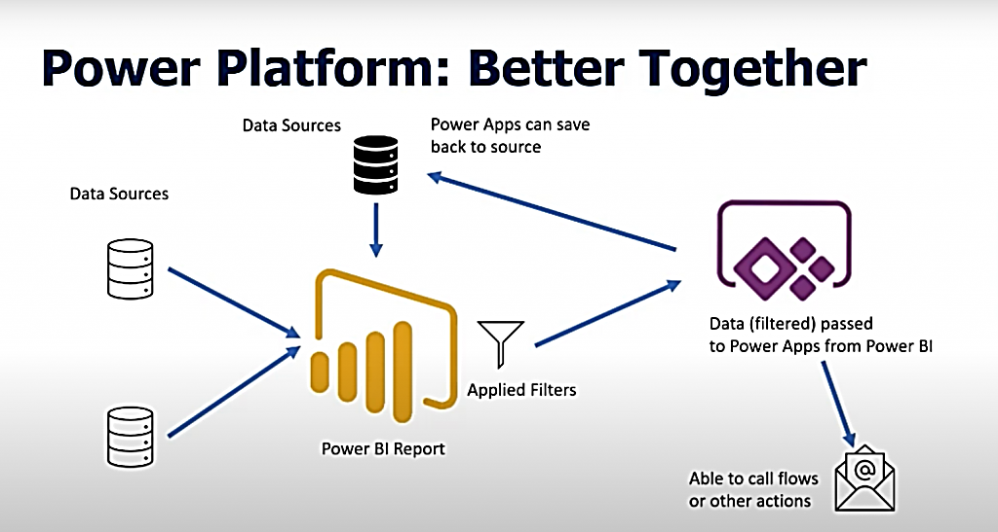

**Integrate Power Apps, Power Automate, and Power BI with SharePoint Online**

**Business scenario**

The company Contoso has a SharePoint Online site where they manage the lifecycle of projects, from request, to approval, to development, to final review. A project requestor, such as a department head, requests an IT project by adding an item to a list. A project approver, such as an IT manager, reviews the project, and then approves it or rejects it. If approved, the project is assigned to a project manager, and additional detail is added to a second list through the same app. A business analyst reviews current and completed projects using a Power BI report embedded in SharePoint. Power Automate is used to send approval email and respond to Power BI alerts.

